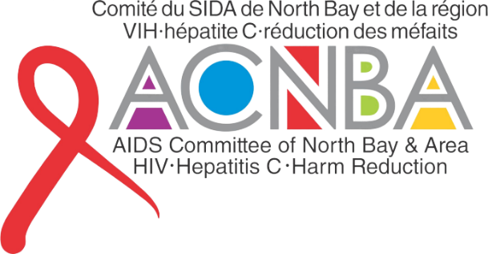
EMPLOYMENT POSTING
The AIDS Committee of
North Bay & Area

Harm Reduction Outreach Worker – Mobile

INTERNAL/EXTERNAL Posting
Salary: $43,636.48 (Annual)
Posted: June 15, 2026
Permanent, as funding permits
Part Time, 35 Hours weekly
Closing: June 29, 2026, at 3pm

_____________________________________________________________________________
Scope of the Position:
The FT Harm Reduction Outreach Worker- Mobile position will provide low threshold outreach to marginalized community members living with/at risk of acquiring HIV and HCV and those at-risk for opioid overdose. This position will coordinate, design and deliver education and training sessions, provide support services and promote referrals to testing and treatment. This position is specifically tasked to provide mobile outreach services to outlying areas of the catchment area and North Bay.
Qualifications:
- 1-2 years of experience working in a community setting;
- Thorough knowledge and experience of HIV, HCV, harm reduction and peer support models;
- Strong knowledge of issues affecting marginalized and HIV/HCV priority populations and communities;
- Experience working with diverse agencies and working successfully in partnership with these agencies;
- Thorough knowledge and understanding of the local health and social service sector, government programs and current legislation that may affect clients;
- Demonstrated ability to work under pressure, to anticipate potential problems/conflicts and take appropriate actions and to meet deadlines;
- Excellent interpersonal, presentation, and communication skills;
- Demonstrated ability to work independently and as a team member within an evolving role in a multi-disciplinary environment;
- Excellent advocacy and negotiation skills;
- Strong commitment to harm reduction, health promotion, community development and adult education;
- Excellent knowledge of MS Word and excel applications and other office related software;
- Ability to work evening and/or weekend shifts;
- Must be able to work in a variety of social and physical settings;
- Because this is a mobile outreach position, candidates MUST have a valid driver’s license and access to a vehicle. Agency van will be used primarily.
- Ability to fundraise effectively and to support existing and future agency fundraisers.

Responsibilities and Related Tasks:
Outreach and Support
- Active outreach in the region/community (including correctional facilities) that are frequented by at risk community members living with/at risk of acquiring HIV/HCV in order to bridge to program and treatment teams;
- Mobile Outreach services to catchment area locations;
- Promote and participate in harm reduction services and distribution of harm reduction supplies (i.e. needle exchange, naloxone)
- Deliver group and individual support and HIV/HCV treatment and prevention education;
- Where appropriate, deliver brief counseling (crisis intervention/’just listening’), indigenous traditional services, and harm reduction teaching including training people to administer naloxone;
- Assist clients with needed paperwork such as applications for birth certificates, health cards or medical appointments and provide referrals to other community, social and health care services, including mental health, addictions, primary care;
- Promote HIV/HCV testing and support those who are tested;
- Assist clients to develop their capacities around treatment/medical scheduling and health management planning, taking into consideration the reality of the relevant social determinants of health for each individual;
- Accompany clients to medical appointments, if requested, to provide emotional support.

Peer Support Program Liaison
- Promote and facilitate the utilization of peer support workers within the agency;
- Promote the inclusion of peers (people with current or former lived experience of drug use) within local harm reduction outreach programs (e.g., recruit, train, supervise and support peers in their roles);
- Schedule and assign support, education and outreach activities to peer workers;
- Assist in providing training on HIV/HCV prevention, education and addiction issues, with a focus on harm reduction to peer support workers;
- Ensure peer support workers have the information and resources to provide information and referral services.

General Administration
- Maintain and revise training materials;
- Routinely compile, enter and report confidential data at agency and funder’s request;
- Ensure that all necessary reports are completed and submitted to the appropriate sources, meeting set deadlines;
- Participate in the planning of program evaluation initiatives;
- Participate as a team member in all team functions- program planning, team meetings and case conferences;
- Network with internal and community partners to ensure an optimal continuum of health & social services through all stages of HIV/HCV education, support, care and treatment;
- Maintain and develop professional competence and learning;
- Participate in agency fundraising activities;
- Perform other related duties as assigned.

ASSETS

Facility in both official languages strongly preferred.
All non-bilingual qualified candidates are encouraged to apply as such applications will be considered in the event a fully qualified bilingual applicant is not selected for the position.

Interested applicants should forward, in print and electronic formats (pdf), a FULL COVER letter of application and interest, resume, contact information for two employment references to be received no later than 3pm Monday, June 29, 2026 or addressed to:

Dr. Stacey Mayhall, Executive Director
The AIDS Committee of North Bay and Area
147 McIntyre St. W., Unit 102
North Bay, Ontario P1B 2Y5
ed@aidsnorthbay.ca
Phone: 705-497-3560
Fax: 705-497-7850

All qualified candidates are encouraged to apply. We value individuals with lived experience with HIV, Hep C or drug use. ACNBA is committed to equity at all levels of the organization and has, as one of its core commitments, the greater and meaningful engagement of people living with HIV and AIDS and HCV. ACNBA specifically encourages members of our priority populations – people living with HIV/AIDS and/or Hep C, cis and trans gay/bi/queer men, cis and trans women, members of diverse ethno-racial communities and members of Indigenous communities (including 2-Spirit people) - to apply and self-identify. While we thank you for your application, only candidates selected for interview will be contacted.

